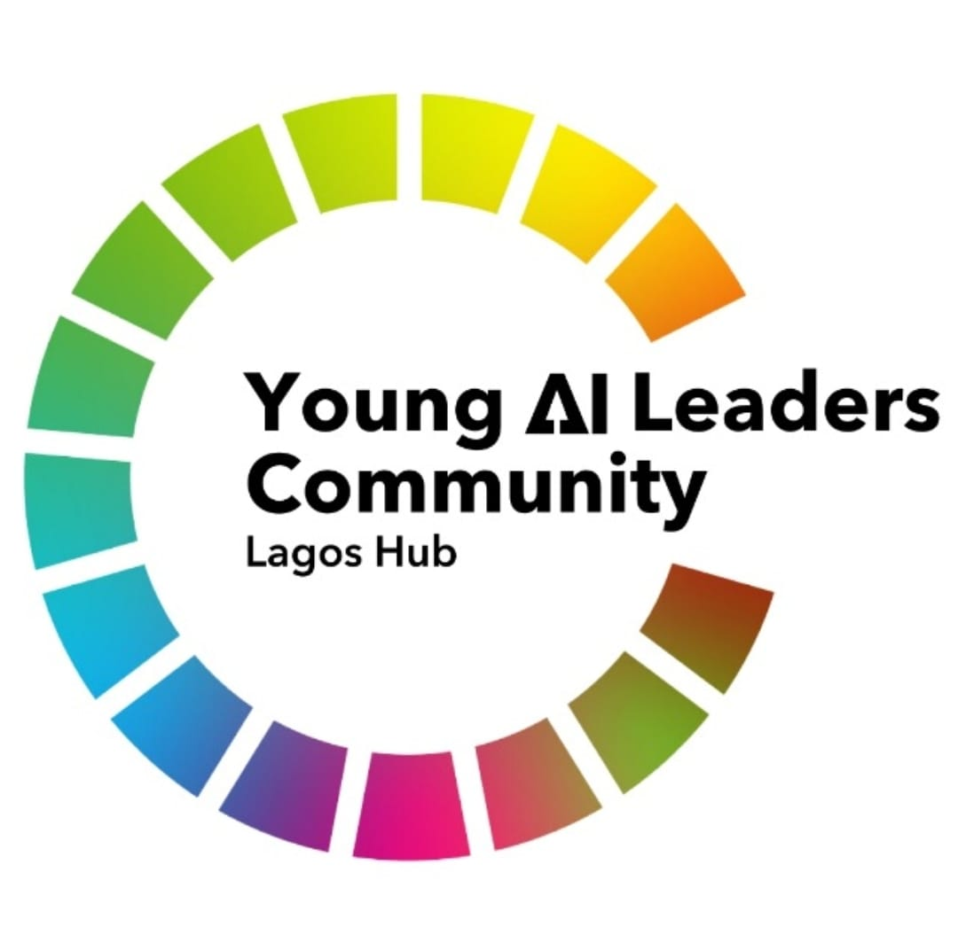**PROFILE - AI for Good Young Leaders Hub (Lagos)**

1. **Full name:** Eunice Adewusi Adebusayo
2. **Preferred name/display name:** Climiradi
3. **Short headline**: Socio-Tech Entrepreneur, AI/ML Engineer, Gender Equity & Climate Justice Activist
4. **Short bio**: AI/ML Engineer and founder of Climiradi Roberts Foundation, empowering 58,000+ young African women through STEAM education, digital skills, and climate-tech innovation, for a climate and gender just world.
5. **Long bio**: Eunice “Climiradi” Adewusi is a final-year Software Engineering student at African Leadership University, Rwanda, whose work spans gender equity, climate justice, and youth empowerment. She founded the Climiradi Roberts Foundation, under which she leads initiatives such as Nexo Girls (digital & STEAM skills for young women) and Project Ayika (a climate-AI fellowship). With active presence in Nigeria, Rwanda and Kenya, her programs have impacted over 58,000 young women across Africa and beyond. As part of the Lagos Hub, she contributes by sharing technical-cum-advocacy expertise, managing partnerships, and leading climate-tech innovations. Recognised by the UN Foundation, Falling Walls Foundation (Germany), WeTech, Women-in-Tech Nigeria, STAND Ireland, Eunice continues to redefine what it means to be a woman in tech.
6. **One-sentence mission statement**: I leverage AI to build inclusive solutions at the intersection of gender equity and climate resilience, ensuring women and vulnerable communities’ voices and lived realities are central to sustainable solutions.
7. **Core skills / areas of expertise**: Machine Learning, Project & People Management, Advocacy, Public Speaking, Partnerships & Communication.
8. **Focus areas/interests**: No Poverty (SDG1), Quality Education (SDG4), Gender Equality (SDG5), Climate Action (SDG13), Partnerships for the Goals (SDG11)
9. **Notable projects/achievements**:

* Climiradi Roberts Foundation (since 2021): Reached 58,000+ youth through our flagship initiatives, Nexo Girls and Project Ayika while advocating for gender justice and climate action.
* #16DaysLoudItQuotes (2023 & 2024): pioneered and organised her college's first GBV campaign that reached 34,796 people in 18+ countries with 43 volunteers (2023) and 39,487 people with 40 student volunteers (2024), raising global awareness on the intersection of tech and gender-based violence.
* UN Foundation Changemaker (2024): Recognised for work in gender-responsive climate policy & youth empowerment.
* Falling Walls Engage Finalist (2025): Recognised in Germany for science engagement for “Breaking the Wall to Women-Led Climate Technology” through Project Ayika.

1. **Social / professional links**: <https://linktr.ee/climiradi>
2. **Anything you want highlighted on the site**:

* A resource (an E-book I wrote) = <https://mailchi.mp/504670a44b0d/go-digital-eunice-adewusi-adebusayo>. OR
* My social impact portfolio = <https://aboutclimiradi.my.canva.site/>